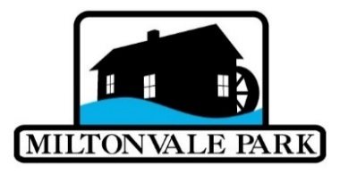
Miltonvale Park Good Neighbour Recognition Award
The Miltonvale Park Good Neighbour Award will be awarded annually at Canada Day. The award will be a certificate and an appropriate gift of up to $100 in value, and will recognize someone who does not live in Miltonvale Park, but contributes to the community.
Nominations will be accepted from residents until the second Friday in June. The Environment and Community Living Committee will meet to review the nominees and make a recommendation to Council for the June meeting. If no nominations are received by the nomination deadline, the Environment and Community Living Committee will put forward two names of non-residents active within the community for consideration by Council.
Nominations shall include the name, photo and address of the nominee, and reasons for the nomination, including an outline of their volunteer activities both within and outside of Miltonvale Park.
Information about Nominee:
Name: _______________________________ Occupation: ____________________
Community/Municipality where Nominee lives: _______________________________
Telephone: ________________ Email address: ______________________________
Approximate number of years lived in the Miltonvale Park: ___________________
Information about Nominator (You):
Name of Person Making Nomination ______________________________________
Signature of Person Making Nomination ____________________________________
Address _____________________________________________________________ ____________________________________________ Postal Code ______________ Email _______________________________________________________________ Telephone _______________ Date of Nomination ___________________________
My reasons for making this nomination: ________________________________________________________________________________________________________________________________________________________________________________________________________________________________________________________________________________________________________________________________________________________________________________________________________________________
Please use additional pages if required.
Please include a short list with information about dates/roles of active participation of the nominee in organizations, and honours earned by the nominee.
Nominations are to be received by the Rural Municipality of Miltonvale Park, 7 B New Glasgow Road – Rte 224, North Milton PE C1E 0S7 or admin@miltonvalepark.com before 4:00 p.m. the second Friday of June annually. Thank you for nominating an inspiring neighbour of Miltonvale Park!

